Histogram and Histogram processing
Brightness:
Brightness refers to the overall lightness or darkness of the image.
If the picture is too low bright we can increase or decrease using brightness method where we add to the each pixel needed bright. So in this homework I used color picture to test (1), when I have redused brightness I found that it becomes darker. So I think this method can be used in night cameras when they take a picture during evening time when it’s not too dark and not too light ,or when we take a picture in sunny day ,picture gets destroyed. And also this method used in medicine in x-ray.
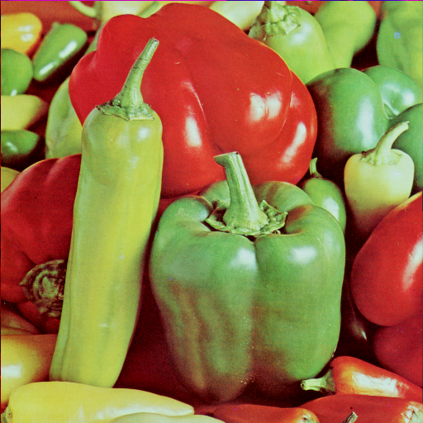
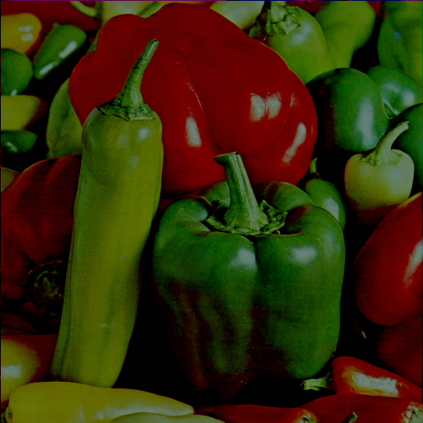

Contrast:
Contrast ,for an example is like sunny day and foggy day.
So In this method I used the picture from brightness and I added some contrast to the picture.
And the result looks pretty good.
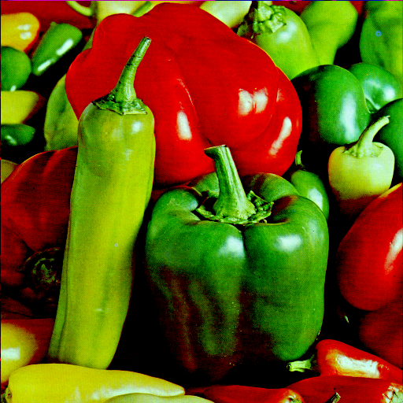

Inverse:

In this method in order to show it exactly how it works I have decided to use black-and-white picture in order to show that it works properly. So in black -and -white all white colors has to be changed to black and all black colors has to be changed to white.


So as you can see original picture starts with black box and ends with black but after inverse method it starts with white and ends with white.

